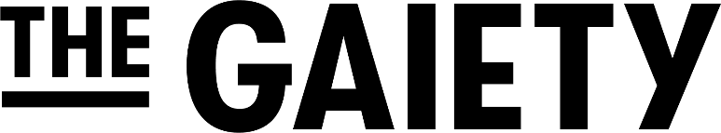
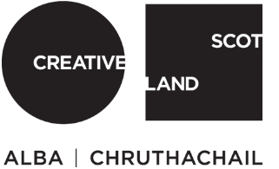

CULTURE COLLECTIVE

Recruiting for-
Creative Practitioners
Creative Practitioner Assistants

We are looking for artists from a variety of different art forms, with a range of experience levels, to deliver work on our Culture Collective programme. We are especially interested in hearing from artists who are based in or have a connection to South Ayrshire communities.

About the roles…

Culture Collective-Creative Practitioners/ Creative Practitioner Assistants

A consultation is currently being undertaken within our South Ayrshire communities to
establish the needs and wants of the community and how culture can play a part. We are therefore actively seeking potential artists who could begin to work with the communities upon the completion of this consultation. We anticipate that this will be from Autumn 2021. We are looking for practitioners from all backgrounds and art forms at different stages of their careers.

We are looking to recruit multiple artists to work on our Culture Collective programme who will have experience in delivering participatory arts work to a range of different individuals and community groups. The artists, whilst working with specific group(s) on their chosen art form, will be artistically guided by the overall vision of the communities in response to the initial consultation and ongoing dialogue.
The artists will play an essential role in working with community groups, being responsive to individuals’ needs, and supporting their creative journey by providing unique and compelling arts activities. All artists’ roles will be supported by our Creative Engagement Coordinator who will be organising the Culture Collective Programme.

The Project
The delivery of the arts programme will commence from Autumn 2021. The artists will have the artistic vision to creatively steer all participating groups towards an artistic outcome, and will be supported by additional production staff, experienced in the creation of live events and/or public art work.
The Culture Collective programme may involve working with children, young people, adults, older people and people with protected characteristics.
The Culture Collective project will be delivered in person in venues such as community centres, church halls and arts venues when Covid restrictions permit and may include working outdoors. However, it may be necessary to deliver at times online, via Zoom (for which support and training can be given).

Who we are
Ayr Gaiety Partnership is the charity and social enterprise that runs The Gaiety Theatre and leads Creative Engagement work across South Ayrshire and beyond.
The Ayr Gaiety is one of twenty-three projects in Scotland that make up The Culture Collective, establishing a network of creative practitioners, organisations and communities working together to create a positive difference locally and nationally in response to COVID-19.

Key knowledge, experience and skills
● Proven track record of working with people of a range of backgrounds to create artistic and fulfilling experiences.
● Experience of working with an equalities, diversity and inclusion approach to support vulnerable group’s involvement.
● Ability to collaborate with and support individuals and communities to create art work that culminates in a multi-art form performance.
● Able to articulate a clear understanding of the importance of the role of the arts in affecting social change and improving the lives of people.
● A positive, proactive, and flexible approach that is responsive to the participants and steering groups’ needs.
● Experience working online and remotely with either one or more of Google, Zoom, MS Teams
● Be willing to work flexibly (working from home, spaces in the communities when Covid restrictions permit and attending workshops (this may include some weekend working)
● Knowledge and/or experience of South Ayrshire would be desirable though not essential.

The Post
These are freelance, part-time temporary posts. Once Creative Practitioners and Creative Practitioner Assistants have been paired with their creative community, the expectation of the delivery programme is a contract lasting between 1-month and 1-year dependent on community needs. We are dependent on the results of the consultation before offering firmer timescales.

Creative Practitioner: £175 per day
Creative Practitioner Assistants: £100 per day

Hours of Work will be flexible and varied. It is anticipated that sessions will commence on a once a week basis, with additional time for introductory meetings and training.
There will be key dates within the project for which we anticipate a full time commitment from the successful candidate, these will be decided in discussion with the final artists.
Depending on how the project pans out, hours may include evening or weekend work. The post holder should ensure flexibility in their availability to meet the needs of the post, many of which are not yet known but we would fully expect some weekends and evenings to be included.

How to apply
If you are interested in applying for either the Creative Practitioners or The Creative Practitioners Assistant, please email your CV and a covering letter (that is no longer than one page) highlighting your experience.
For the Creative Practitioner role, please also include examples of your work, with links to your website or project examples if you have them.

Please make sure you add, ‘Creative Practitioner or Creative Practitioner Assistant’ into the email subject heading.
Ensure that your CV details two references, that we can contact with your permission (we will only take up references if we are offering you the position).
Email to- creative.engagement@ayrgaiety.co.uk
The Ayr Gaiety is committed to access, diversity and representation, and we actively encourage applicants from different backgrounds and with different experiences in order to develop and strengthen the organisation, evolve our programmes, and better reflect the communities we serve.

Applications Close: Midnight Friday 5th of November.

